**Name _____________________________________________________**

**Geometry Pre-IB Mid-term Review**

**Constructions**

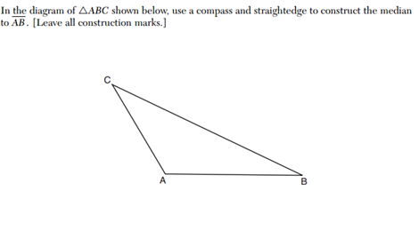1)

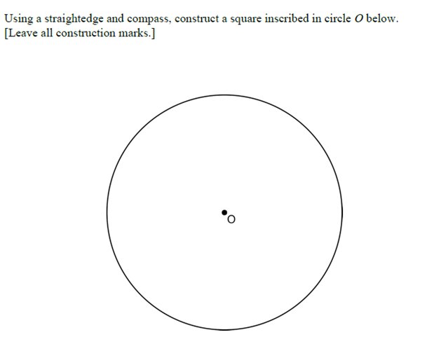**2)**

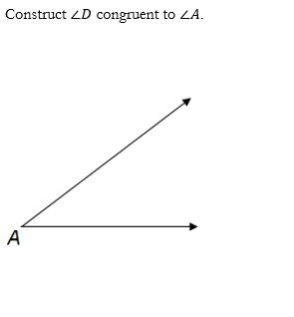 3)

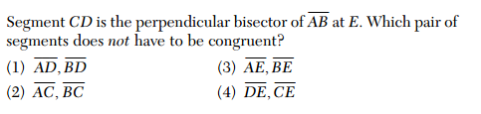

4.

5)The diagram below shows the construction of the bisector of .

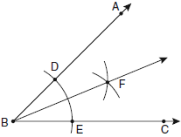

Which statement is *not* true?

|  |  |  |  |
| --- | --- | --- | --- |
| 1) |  | 3) |  |
| 2) |  | 4) |  |

6)Using a compass and straightedge, construct the bisector of . [Leave all construction marks.]

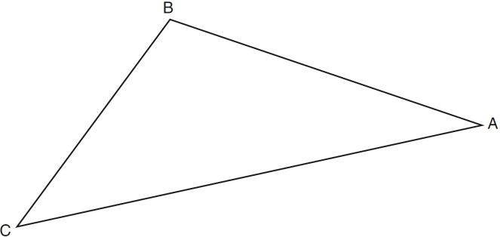

7)Using a compass and straightedge, construct an equilateral triangle with  as a side. Using this triangle, construct a 30° angle with its vertex at *A*. [Leave all construction marks.]

**

8)The diagram below shows the construction of an equilateral triangle.

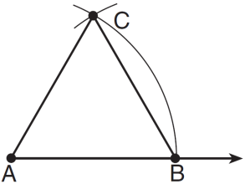

Which statement justifies this construction?

|  |  |
| --- | --- |
| 1) |  |
| 2) |  |
| 3) |  |
| 4) |  |

|  |  |
| --- | --- |
|  |  |
|  |  |
|  |  |

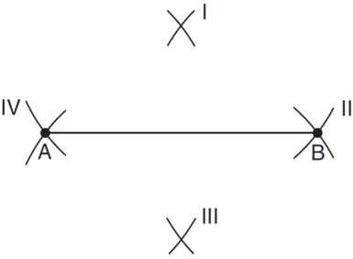9)Line segment *AB* is shown in the diagram below.

Which two sets of construction marks, labeled I, II, III, and IV, are part of the construction of the perpendicular bisector of line segment *AB*?

|  |  |
| --- | --- |
| 1) | I and II |
| 2) | I and III |
| 3) | II and III |
| 4) | II and IV |

**Theorems and Vocabulary and Properties (int/ext angle, sum of int angles of triangle, isosceles triangle)**

10)When writing a geometric proof, which angle relationship could be used alone to justify that two angles are congruent?

|  |  |  |  |
| --- | --- | --- | --- |
| 1) | supplementary angles | 3) | adjacent angles |
| 2) | linear pair of angles | 4) | vertical angles |

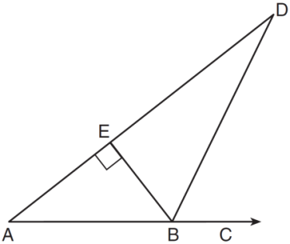11)The diagram below shows , with , , and . If , what is ?

|  |  |
| --- | --- |
| 1) | 26 |
| 2) | 38 |
| 3) | 52 |
| 4) | 64 |

12)Triangle *PQR* has angles in the ratio of . Which type of triangle is ?

|  |  |
| --- | --- |
| 1) | acute |
| 2) | isosceles |
| 3) | obtuse |
| 4) | right |

13)In , the measure of angle *A* is fifteen less than twice the measure of angle *B*. The measure of angle *C* equals the sum of the measures of angle *A* and angle *B*. Determine the measure of angle *B*.

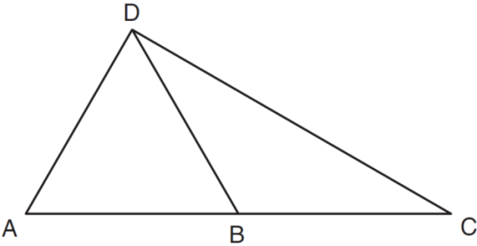 14)In the diagram below of *,* *B* is a point on  such that  is an equilateral triangle, and  is an isosceles triangle with . Find . Explain your reasoning.

15)In the diagram of  shown below,  is drawn from vertex *B* to point *A* on , such that .

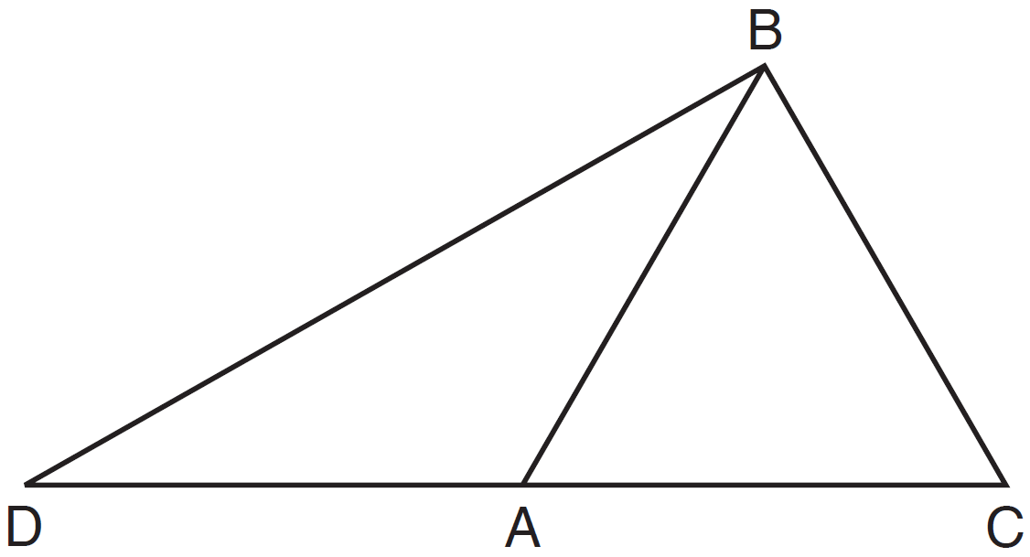

In , , , and . In ,  and . [Only algebraic solutions can receive full credit.] Find . Find . Find the length of . Find the length of .

16) Hersch says if a triangle is an obtuse triangle, then it cannot also be an isosceles triangle. Using a diagram, show that Hersch is incorrect, and indicate the measures of all the angles to justify your answer.

17)In the diagram below of *,* side  is extended through *P* to *T*, , , and . Find .

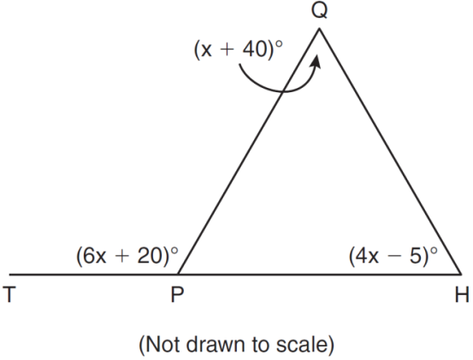

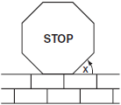18)A stop sign in the shape of a regular octagon is resting on a brick wall, as shown in the accompanying diagram.

What is the measure of angle *x*?

|  |  |
| --- | --- |
| 1) | 45° |
| 2) | 60° |
| 3) | 120° |
| 4) | 135° |

19)The measure of an interior angle of a regular polygon is 120°. How many sides does the polygon have?

20)The sum of the interior angles of a regular polygon is 540°. Determine and state the number of degrees in one interior angle of the polygon.

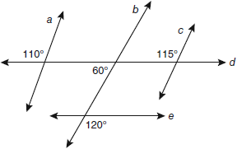**Parallel Lines**

21)Based on the diagram below, which statement is true?

|  |  |
| --- | --- |
| 1) |  |
| 2) |  |
| 3) |  |
| 4) |  |

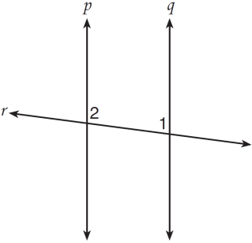

22)Lines *p* and *q* are intersected by line *r*, as shown below.

If  and , for which value of *x* would ?

|  |  |
| --- | --- |
| 1) | 17 |
| 2) | 24 |
| 3) | 83 |
| 4) | 97  23) |

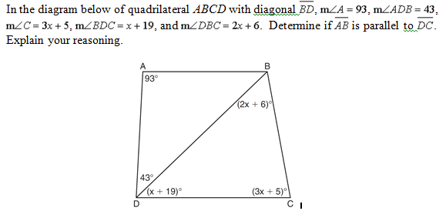

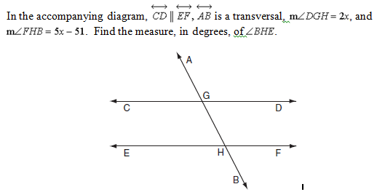

24)

25)

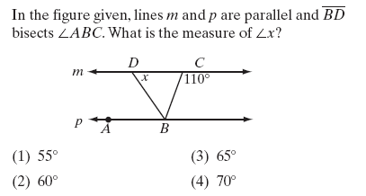

26)

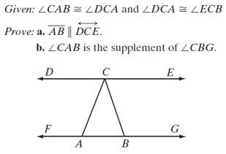

27)

Given:  || 

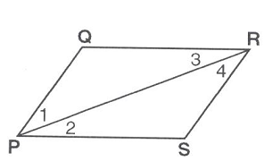Prove:  || 

**Rotations**

28)What is the image of point  under the rotation  about the origin?

|  |  |
| --- | --- |
| 1) |  |
| 2) |  |
| 3) |  |
| 4) |  |

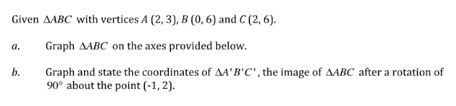29)

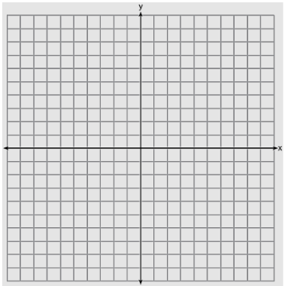

30. Using a compass, rotate the given triangle about point P. Use reference angle below.

P

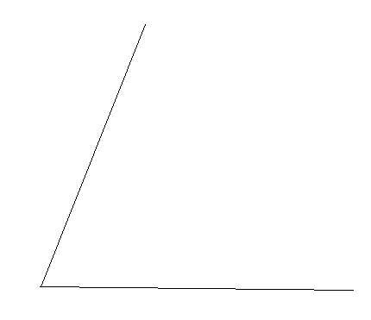

**Reflections**

31)

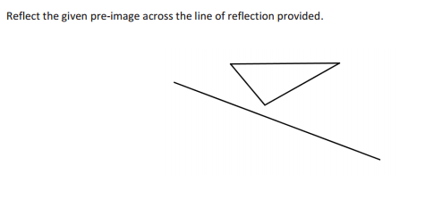

32)What are the coordinates of point *P,* the image of point  after a reflection in the line **?

|  |  |
| --- | --- |
| 1) |  |
| 2) |  |
| 3) |  |
| 4) |  |

Side Note: What would the image be after a reflection in the x-axis? ______________ y-axis?_______________

**Translations**

33)A translation moves  to . What are the coordinates of the image of point  under the same translation?

|  |  |
| --- | --- |
| 1) |  |
| 2) |  |
| 3) |  |
| 4) |  |

34) If the transformation  maps point  onto point , what is the value of *x*?

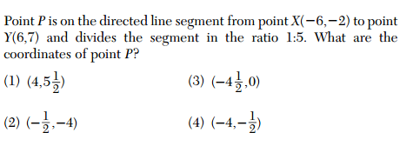35)

**Composition of Transformations**

36)What is the image that results from this composition of transformations?



37)The coordinates of  are *,* *,* and *.* What are the coordinates of the vertices of its image after the transformation ?

|  |  |
| --- | --- |
| 1) |  |
| 2) |  |
| 3) |  |
| 4) |  |

**Extra Transformations**–

38)Which transformation is *not* always a rigid motion?

|  |  |
| --- | --- |
| 1) | rotation |
| 2) | dilation |
| 3) | reflection |
| 4) | translation |

39)A transformation of a polygon that always preserves both length and orientation is

|  |  |
| --- | --- |
| 1) | dilation |
| 2) | translation |
| 3) | line reflection |
| 4) | None of the above |

40)

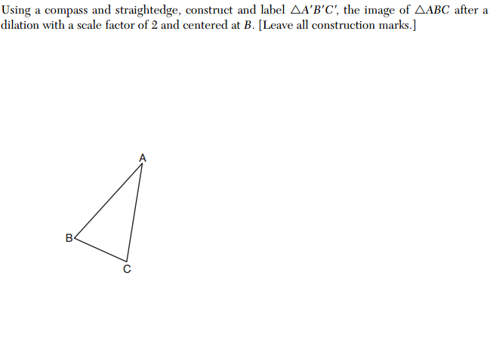

41)The vertices of  are , , and . Identify and graph a transformation of  such that its image, ,results in .

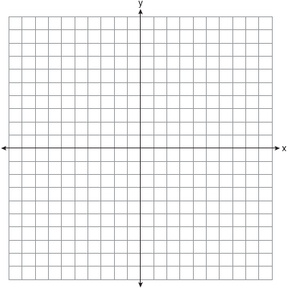

42)

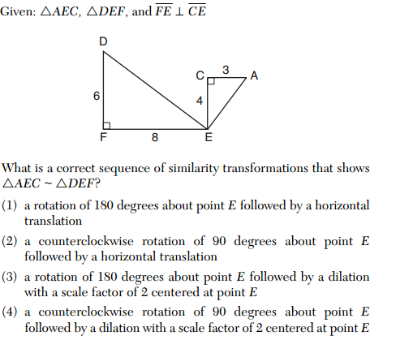

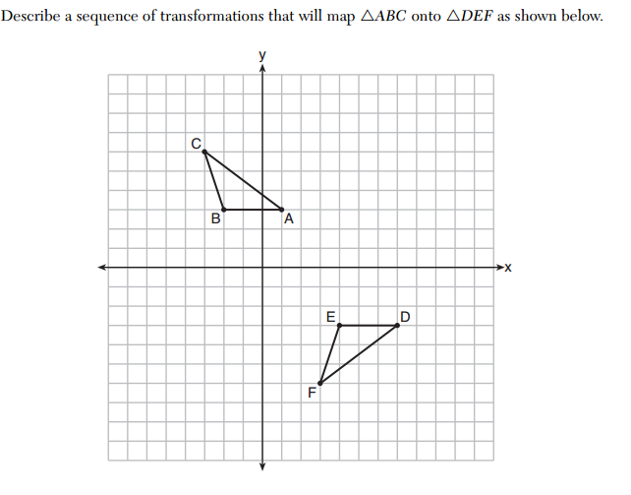43)

**Triangle Congruence**

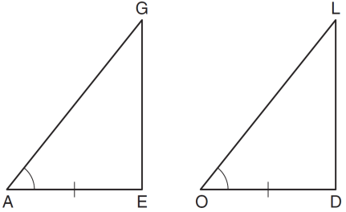 44)In the diagram below of  and , , and .

To prove that  and  are congruent by SAS, what other information is needed?

|  |  |
| --- | --- |
| 1) |  |
| 2) |  |
| 3) |  |
| 4) |  |

45)In the diagram below, .

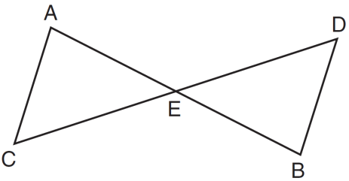

Which statement is *not* always true?

|  |  |
| --- | --- |
| 1) |  |
| 2) |  |
| 3) |  |
| 4) |  |

46)

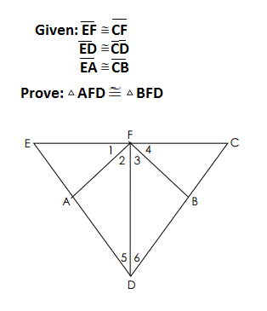

47)

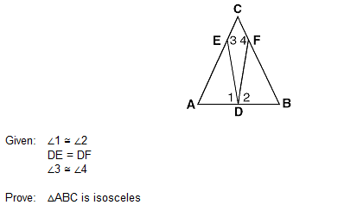

48)

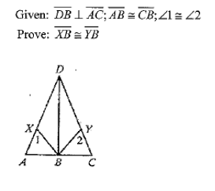

**Coordinate Geometry**

49) The endpoints of ** are ** and **. Determine and state the length of ** in simplest radical form.

50) What is the slope of the altitude to side AB, A(-2, 1), B(4, -5), C(2, 6)?

51) If a line segment has endpoints  and , what are the coordinates of the midpoint of ?

52)



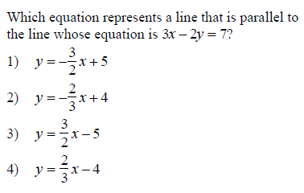53)

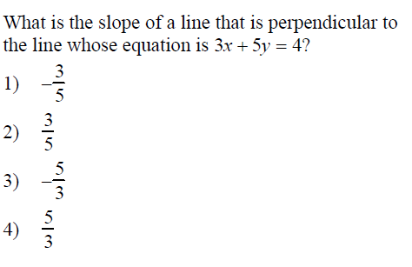54)

55) Which equation represents the perpendicular bisector of AB whose endpoint are A(8,2) and B(0,6)? Express your answer in slope-intercept form.

56)

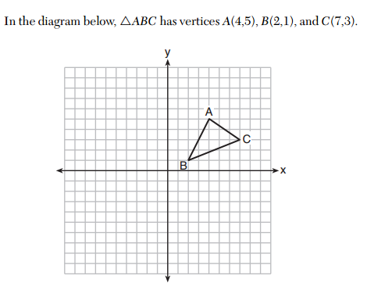

Write the equation of the median to side AB.

57) A line that passes through the points whose coordinates are (1, 1) and (5, 7) is dilated by a scale factor of 4.

A) Write the equation of the image if the center of dilation is the origin.

B) Write the equation of the image if the center of dilation is (5, 7).

**Right Triangles**

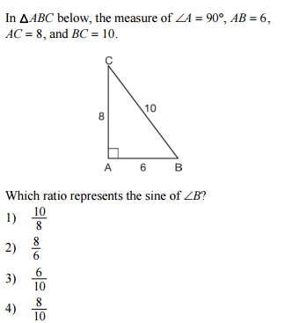58)

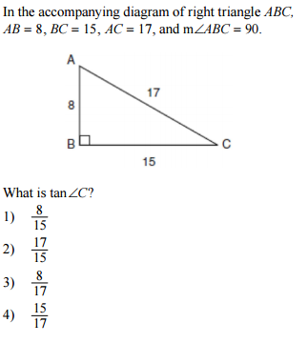

59)

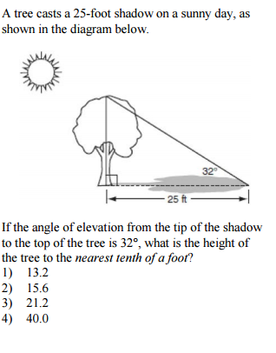60)

61) Ron and Francine are building a ramp for performing skateboard stunts, as shown in the accompanying diagram. The ramp is 7 feet long and 3 feet high. What is the measure of the angle, *x*, that the ramp makes with the ground, to the *nearest tenth of a degree?*

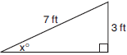

1. In the accompanying diagram, a ladder leaning against a building makes an angle of 58º with level ground. If the distance from the foot of the ladder to the building is 6 feet, find, to the *nearest foot*, the length of the ladder.

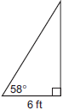

63) A communications company is building a 30-foot antenna to carry cell phone transmissions. As shown in the diagram below, a 50-foot wire from the top of the antenna to the ground is used to stabilize the antenna.

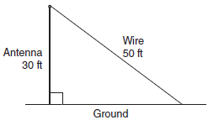

Find, to the *nearest degree,* the measure of the angle that the wire makes with the ground.